**Problem 1:**

In a company, named “ABC Pvt Ltd,” there are several departments, employees and projects. Each employee is part of some department, and every department controls some projects. The projects are run by the employees. Now, there are certain situations.

1. Each department must have some employees.

2. One department can control many numbers of projects, and at the same time, a department might have no project at all.

3. Each employee has to work on some project, and one can be part of more than one project.

4. Each employee has different work hours on various projects. Design an ER-Diagram for this company.

Each employee has the following information.

*--- eid, ename, sex, dob, joindate, salary*

Each department has the following information.

*--- did, dname, location*

Each project has the following information.

--- pid, pname, startdate, deadline

ER-DIAGRAM:

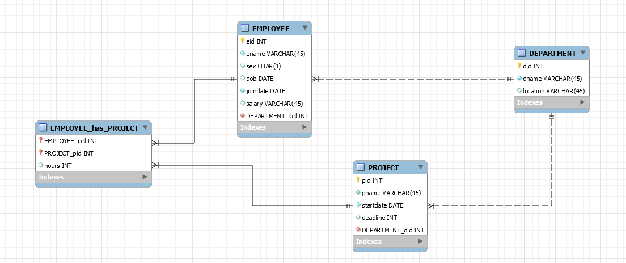

DATA:

DEPARTMENT

|  |  |  |
| --- | --- | --- |
| did | dname | location |
| 101, | 'Production', | 'Gurgaon' |
| 201, | 'Assembly', | 'Noida' |
| 301, | 'Marketing', | 'Delhi' |

PROJECT

|  |  |  |  |  |
| --- | --- | --- | --- | --- |
| pid | pname | startdate | deadline | DEPARTMENT_did |
| 1011 | Special CMOS gate for BEL | 2017-01-01 | 36 | 101 |
| 1012 | RAM for KINGSTON | 2017-06-01 | 36 | 101 |
| 2011 | mother board for ASUS | 2017-01-01 | 24 | 201 |
| 2012 | mother board for ACER | 2017-09-01 | 24 | 201 |
| 3011 | target new assembly contract | 2018-06-01 | 6 | 301 |

EMPLOYEE

|  |  |  |  |  |  |  |
| --- | --- | --- | --- | --- | --- | --- |
| `eid` | `ename` | `sex` | `dob` | `joindate` | `salary` | `DEPARTMENT_did` |
| 1101 | Ram Yadav | M | 1988-04-12 | 2017-01-25 | 19000 | 101 |
| 1102 | Raghav P | M | 1985-06-10 | 2017-11-05 | 18000 | 101 |
| 1103 | M Reddy | M | 1990-06-17 | 2018-01-10 | 15000 | 101 |
| 2101 | Megha | F | 1989-08-10 | 2017-07-01 | 21000 | 201 |
| 2102 | Karanvir | M | 1985-12-10 | 2017-11-05 | 20000 | 201 |
| 2103 | Sundar S | M | 1991-02-15 | 2018-06-15 | 15000 | 201 |
| 3101 | Rama P | F | 1985-06-10 | 2017-02-05 | 30000 | 301 |
| 3102 | Radhika Bera | F | 1991-08-22 | 2017-06-15 | 27000 | 301 |

EMPLOYEE_has_PROJECT

|  |  |  |
| --- | --- | --- |
| EMPLOYEE_eid | PROJECT_pid | hours |
| 1101 | 1011 | 4 |
| 1101 | 1012 | 4 |
| 1102 | 1011 | 6 |
| 1102 | 1012 | 2 |
| 1103 | 1012 | 8 |
| 2101 | 2011 | 8 |
| 2102 | 2011 | 2 |
| 2102 | 2012 | 6 |
| 2103 | 2012 | 8 |
| 3101 | 3011 | 8 |
| 3102 | 3011 | 8 |

Solution:

select database();

create database ABC_DB;

use ABC_DB;

show tables;

describe employee;

INSERT INTO `abc_db`.`employee`

(`eid`,

`ename`,

`sex`,

`dob`,

`joindate`,

`salary`,

`DEPARTMENT_did`)

VALUES

(123,

'Ram',

'M',

'1988-04-12',

'2017-01-22',

45000,

12);

INSERT INTO `abc_db`.`department`

(`did`,

`dname`,

`location`)

VALUES

(101,

'Production',

'Gurgaon');

INSERT INTO `abc_db`.`department`

(`did`,

`dname`,

`location`)

VALUES

(201,

'Assembly',

'Noida');

INSERT INTO `abc_db`.`department`

(`did`,

`dname`,

`location`)

VALUES

(301,

'Marketing',

'Delhi');

select * from department;

INSERT INTO `abc_db`.`employee`

(`eid`,

`ename`,

`sex`,

`dob`,

`joindate`,

`salary`,

`DEPARTMENT_did`)

VALUES

(1101,

'Ram Yadav',

'M',

'1988-04-12',

'2017-01-25',

19000,

101);

INSERT INTO employee VALUES (1102, 'Raghav P', 'M', '1985-06-10', '2017-11-05', 18000, 101);

INSERT INTO employee VALUES (1103, 'M Reddy', 'M', '1990-06-17', '2018-01-10', 15000, 101);

INSERT INTO employee VALUES (2101, 'Megha', 'F', '1989-08-10', '2017-07-01', 21000, 201);

INSERT INTO employee VALUES (2102, 'Karanvir', 'M', '1985-12-10', '2017-11-05', 20000, 201);

INSERT INTO employee VALUES (2103, 'Sundar S', 'M', '1991-02-15', '2018-06-15', 15000, 201);

INSERT INTO employee VALUES (3101, 'Rama P', 'F', '1985-06-10', '2017-02-05', 30000, 301);

INSERT INTO employee VALUES (3102, 'Radhika Bera', 'F', '1991-08-22', '2017-06-15', 27000, 301);

SELECT * FROM EMPLOYEE;

INSERT INTO PROJECT VALUES (1011, 'Special CMOS gate for BEL', '2017-01-01',36,101);

INSERT INTO PROJECT VALUES (1012, 'RAM for KINGSTON', '2017-06-01',36,101);

INSERT INTO PROJECT VALUES (2011, 'mother board for ASUS', '2017-01-01',24,201);

INSERT INTO PROJECT VALUES (2012, 'mother board for ACER', '2017-09-01',24,201);

INSERT INTO PROJECT VALUES (3011, 'target new assembly contract', '2018-06-01', 06, 301);

select * from Project;

describe project;

INSERT INTO employee_has_project VALUES (1101, 1011, 4);

INSERT INTO employee_has_project VALUES (1101, 1012, 4);

INSERT INTO employee_has_project VALUES (1102, 1011, 6);

INSERT INTO employee_has_project VALUES (1102, 1012, 2);

INSERT INTO employee_has_project VALUES (1103, 1012, 8);

INSERT INTO employee_has_project VALUES (2101, 2011, 8);

INSERT INTO employee_has_project VALUES (2102, 2011, 2);

INSERT INTO employee_has_project VALUES (2102, 2012, 6);

INSERT INTO employee_has_project VALUES (2103, 2012, 8);

INSERT INTO employee_has_project VALUES (3101, 3011, 8);

INSERT INTO employee_has_project VALUES (3102, 3011, 8);

select * from employee;

select * from employee_has_project;